**Customer Portal Guide**

Welcome to LMN’s Customer Portal! The Portal was designed to allow Customers of Contractors to make Payments Online, review, approve Estimates, submit Work Requests, and communicate in *real-time* with your Contractor.   
  
To access the Customer Portal, the Contractor will send you a ‘Welcome Email’ to create an account.

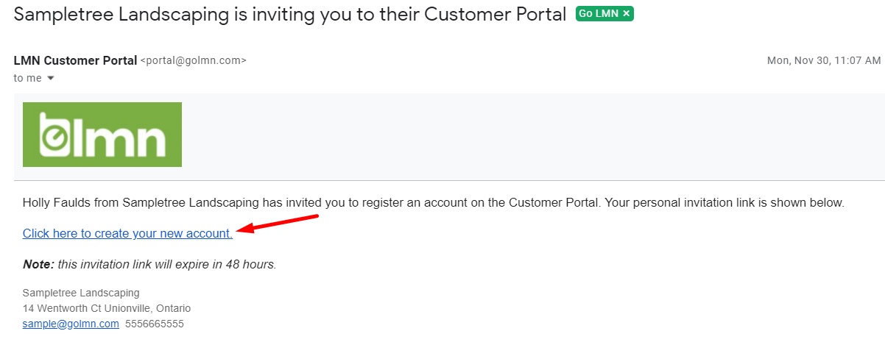

**Step 1: Create Your Customer Portal Account**

Simply click the link to create your Customer Portal account to establish a login. Please note the registration link will expire in 5 days.  If the link has expired, please contact the Contractor to ask them to resend the invite.

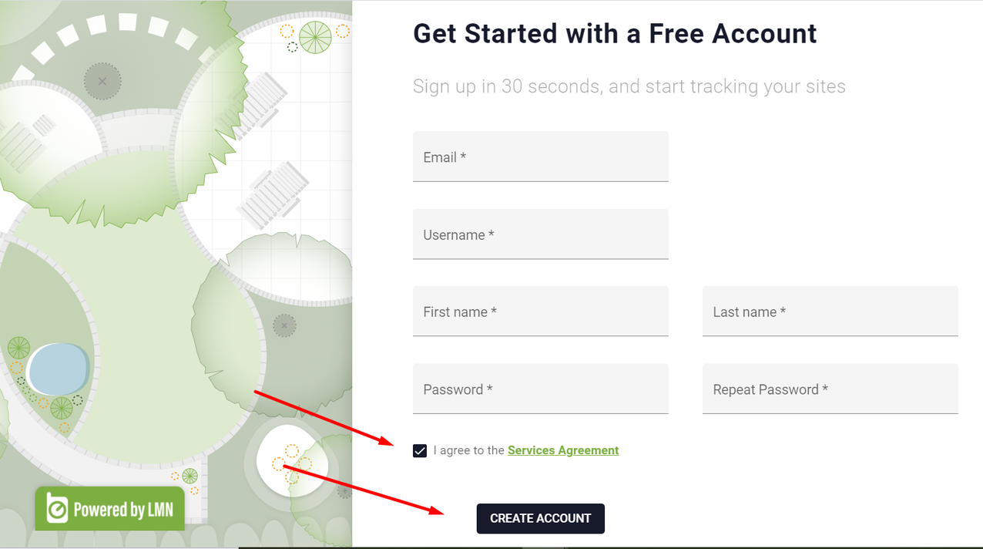

Once your account is created, *bookmark* to your browser for ease of use. Also note, if you have forgotten your login credentials, please click the “forgot username or password” button.  
  
Log in to the Customer Portal to Pay Invoices Online, view Estimates, and submit Work Requests. If applicable, you may add additional Portal users to your account and provide the same or modified access. Setup your **Profile** by **enabling email notifications** to receive an alert if an Invoice or Estimate has been published to your Portal.

**Step 2: Pay Invoices Online**

In order to make Payment Online, you will need to add a Payment Method. You will find this option under the **Profile** tab.  **TIP** Once a Payment Method is added, you can setup **auto-charge** for recurring monthly invoices.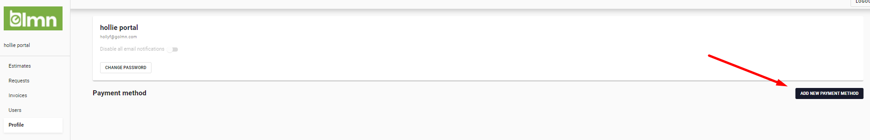

Click **Add New Payment Method** to add your desired credit card and/ or ACH payment. Please note, check with your Contractor if they accept ACH).

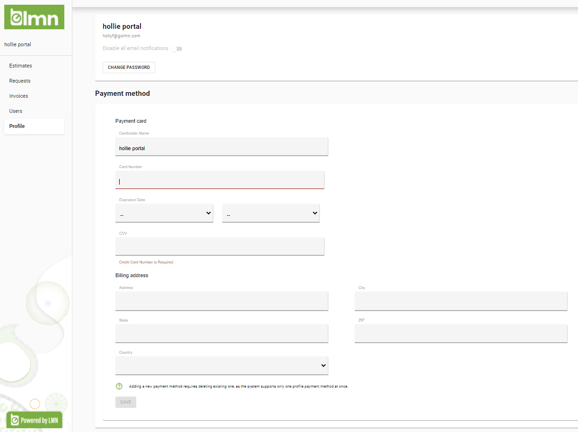

To make a Payment against an Invoice that has been published to the Customer Portal, click the **Invoices** tab and select the applicable Invoice. Once viewed, you can download the Invoice for your records and click **Checkout.** Select Payment Method and select **Pay Now.**

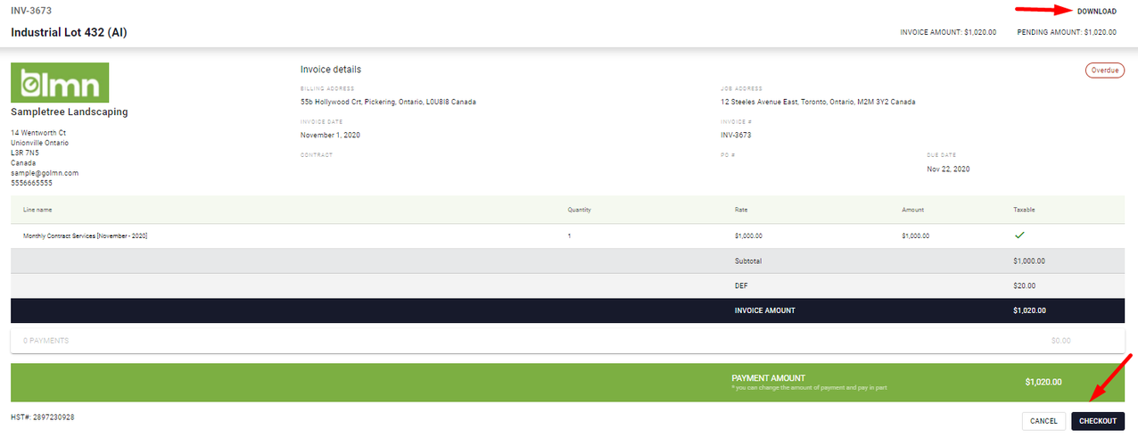

### Setup Auto-Charge

In your Customer Portal Account, select **Profile** and **Add New Payment Method,** and select **Use for auto-charge.**

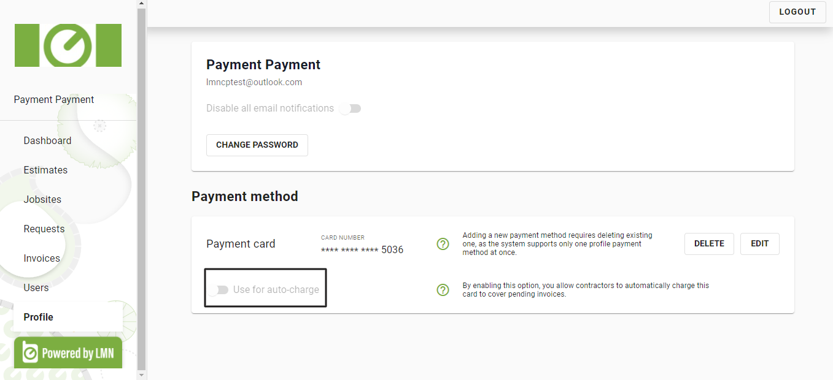

Enter the **limit** you want to authorize for auto-charge(s) to your card and click **Save.**

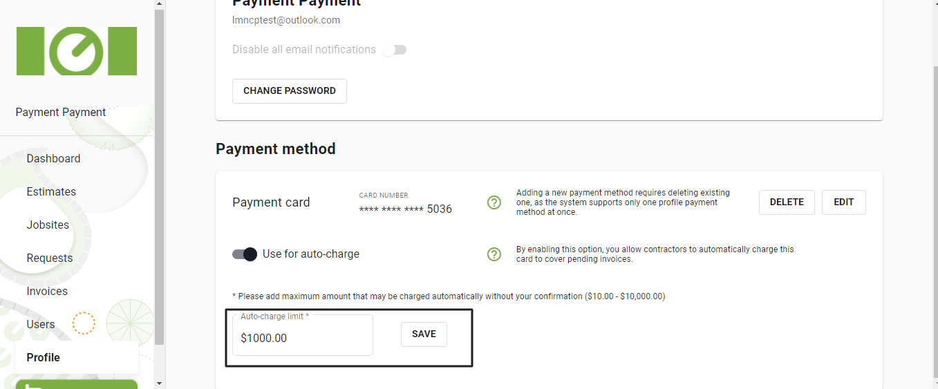

**Step 3: Review, Approve and Comment on Proposed Work**

To review, approve, request change, or comment on an Estimate proposed by Contractor, click **Estimates** tab:

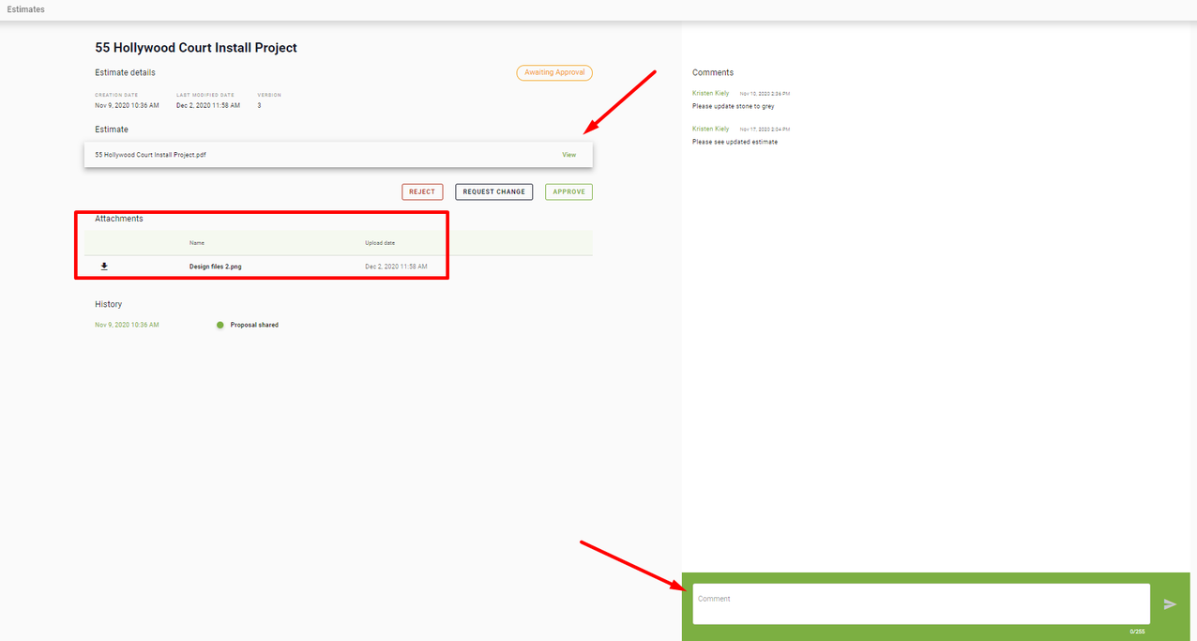

**Step 4: Have a Work Request? Easily submit Work Request(s) to your Contractor right within the Portal**

To submit a Work Request, click **Requests** >**Submit New Request** and fill in the required details of your request:

